MEMBERSHIP APPLICATION FORM – OVERSEAS

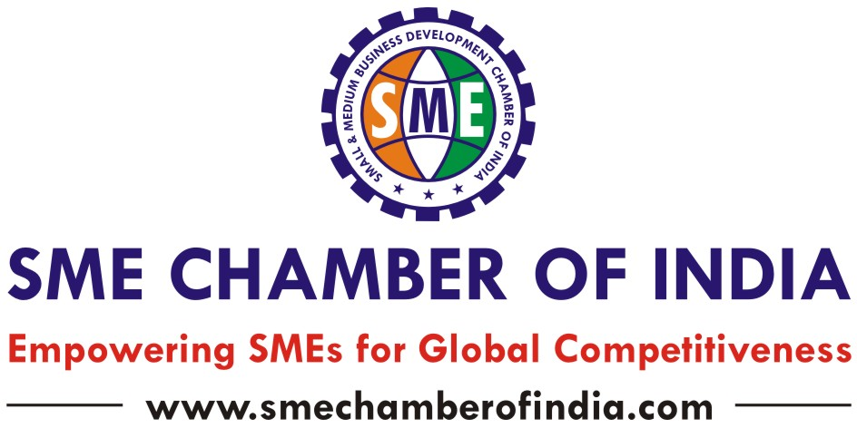

- - - - - - - - - - - - - - - - - - - - - - - - - - - - - - - - - - - - - - - - - - - - - - - - - - - - - - - - - - - - - - - - - - - - - - - - - - - - - - - - - - - - - - - - - - - - - - - - - - - - - - - - - - - - - - - - - - -- - - - - - - - - - - - - - - -
Registered & Head Office: 5, Upper Ground Floor, Samruddhi Venture Park, Marol MIDC Industrial Estate, Andheri (E), Mumbai – 93. INDIA.
Tel: +91 – 22 – 6150 9800 / 6667 4444 | Fax: +91 – 22 – 2825 0414
Email: director@smechamber.com | president@smechamber.com | Website: www.smechamberofindia.com
- - - - - - - - - - - - - - - - - - - - - - - - - - - - - - - - - - - - - - - - - - - - - - - - - - - - - - - - - - - - - - - - - - - - - - - - - - - - - - - - - - - - - - - - - - - - - - - - - - - - - - - - - - - - - - - - - - -- - - - - - - - - - - - - - - -
Name of the Company:
Name and Designation of the Applicant:
Contact Details: Tel: Mobile No: E-mail:
Main Business Activities:
Industry or Business sector:
Business Interest:
Type of Company: |  Manufacturing  Exporter  Importer  Law Firm  IT  Business Consulting  Exhibition Organiser  ICT  SEZ   Service Industry  Marketing  Distributor  Association  Financial Institutions  Others _______________
Status of Company: Date of Incorporation:
Registered Office Address
Total Turnover of Company for last 3 years (in USD / Euro / Sterling Pound) | Previous Year 2 | Previous Year 1 | Last Year
Details of products or services to be exported to India:
Details of products or services to be imported from India:
Are you looking for Indian company for Joint Ventures / Technology /Transfers / Contract Manufacturing tie ups in India:
Are you looking to invest in India, particularly in any Project or Industry?
Are you interested to be the Partner for Indian companies in your Country? Please provide details:
Are you looking for Marketing or Distributor Partner in India?
Are you interested to set up Manufacturing unit in India?
Do you need Industrial Premises or Industrial land?
Are you looking for Market or Product Research?
Are you looking for any Franchise or Channel Partner in India?
Are you looking to promote Advance Technology, Turnkey Projects in India? Please provide details:
What kind of Advisory Services and Assistance needed from the Chamber?
Awards and Recognitions, if any, please provide details:
Are you interested to participate in activities or events in India?
Any other specific support required?

MEMBERSHIP - CATEGORIES & FEE

Sr. No | Membership  Category | Who Can Apply for Membership? | Annual  Membership Fee
I | Small companies  (Turnover up to USD 15 million) | Small & Medium Manufacturers, Exporters, Importers, Buying or Selling Agents, Distributors, Suppliers, Service Providers, Consulting Companies, Professionals, Start-Ups, Entrepreneurs, Marketing & Exhibitions Organisers, logistics and allied companies | USD 3000  Plus 18% GST
II | Medium companies  (Turnover from USD 15 million to USD 50 million ) |  | USD 7500  Plus 18% GST
III | Corporate  (Turnover above USD 50 million) | Public Limited & Multinational Companies, Investment Board, Overseas Banks & Financial Institutions, SEZ, Industrial parks, Technology park and International Business Companies / Organisations, Venture Capital / Private Equity Fund | USD 150000  Plus 18% GST
IV | Patron Membership  (By invitation) | Senior executive or Representatives of corporate / FIIs / MNCs / Trade Promotion organisations / government agencies / Venture Capital / Private Equity Fund and Individuals | USD 10,000  Plus 18% GST
V | Associate Organisation | Chamber of Commerce, Associations, Government Agencies, NGOs and Other International Organisations | USD 3000  Plus 18% GST

Membership fee payment details
Bank Details:
Company Name: Macro Corporate Services Pvt Ltd | Bank A/c No.: 02122000004814 | Bank Name: HDFC Bank Ltd
Bank Address: Gr Fl, Yashodham, Central A K Vaidya Marg Mum –400 063 | IFSC Code: HDFC0000212 | MICR No: 400240037 | SWIFT CODE: HDFCINBB

Note: Macro Corporate Services Pvt Ltd. is authorized to collect membership subscription / delegate fee / overseas sponsorship and donations on behalf of SME Chamber of India

Yours Sincerely,
Applicant Name: __________________________ Designation: ________________ Date: ___________
- - - - - - - - - - - - - - - - - - - - - - - - - - - - - - - - - - - - - - - - - - - - - - - - - - - - - - - - - - - - - - - - - - - - - - - - - - - - - - - - - - - - - - - - - - - - - - - - - - - - - - - - - - - - - - - - - - -- - - - - - - - - - - - - - - - Important Notes / Terms & Conditions
- Membership Fee to be transferred along with membership form
- Request by mail for obtaining Membership as well as business interest
- Company Profile
- Acceptance / refusal of membership will be at the sole discretion of the Managing Committee of the Chamber.
- The Chamber reserves its rights to reject or hold any application without assigning any reason.
- No refund will be given for cancellation of any type of Membership for any reason whatsoever.
- Incomplete Application Forms and those do not fulfill the above requirements will not be accepted.
- Membership is for the purpose of obtaining general services. Certain services will be defined on the requirement of the Company and will be chargeable according to nature of services
- - - - - - - - - - - - - - - - - - - - - - - - - - - - - - - - - - - - - - - - - - - - - - - - - - - - - - - - - - - - - - - - - - - - - - - - - - - - - - - - - - - - - - - - - - - - - - - - - - - - - - - - - - - - - - - - - - -- - - - - - - - - - - - - - - -

